Manoj Kumar,D.K. Yadav, Ankur Singh, Vijay Kr. Gupta (2015). A Movie Recommender System: MOVREC, International Journal of Computer Applications 124(3), 1-49.
Main research question:
This paper introduces a movie recommendation system MOVREC which is based on collaborative filtering methods. The recommended movie list is sorted according to the ratings and it uses K-means algorithm.
Introduction
- Collaborative filtering approach: similarity measures between users and/or items.
++ content-independent, no need to build features
++ explicit ratings to real quality assessment of items
++ user’s similarity rather than item’s similarity
- Content-based filtering approach: describe items apart from user’s profile to indicate user’s preferred liked or dislikes.
++ Hybrid Recommender Systems
++add a set of attributes: actor, director, genre, year and rating
Methodology
- Basic K-means algorithm
- Data description: genre, actor, director, year, rating
Input: a number of movies: m
Output: a number of clusters: K
Step 1 Select n movies from m movies n<m
Step 2 If n>20 then select top 20 movies from n movies
based on ratings.
Else display the output movies sorted by rating.
Step 3 If rating of movies x, y are equal i.e. If
Rx= Ry
Then select those movies which have greater number of user votes.
Step 4 Assume K=4.
Step 5 REPEAT (6, 7)
Step 6 Chose initial centroid C1, C2, C3, C4.
Step 7 Calculate Euclidean distance of all data points
w.r.t. C1, C2, C3, C4 and re-compute the centroid of
each cluster.
Step 8 UNTILL centroid does not change.
m: Total number of movies in database
n: Number of movies after user query
x, y: Two random movies
Rx, Ry: Rating of movies x, y
K: Number of cluster
C1, C2, C3, C4: Initial Centroid.

- This paper use the weightage and matching of attributes
- Actor weight: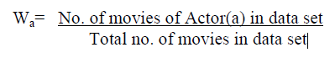
- Director weight: 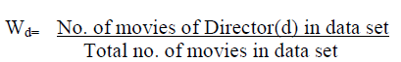
- Rating(depended on # votes to set categories):
- Genre weight: 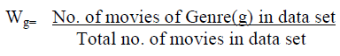
- Year weight: 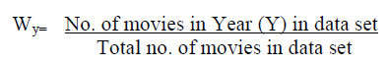
Total weight of a movie: 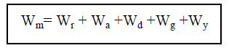

This paper introduces how to use k-means algorithm to recommend movies but not test accuracy.

